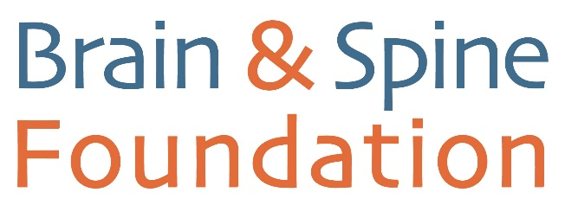

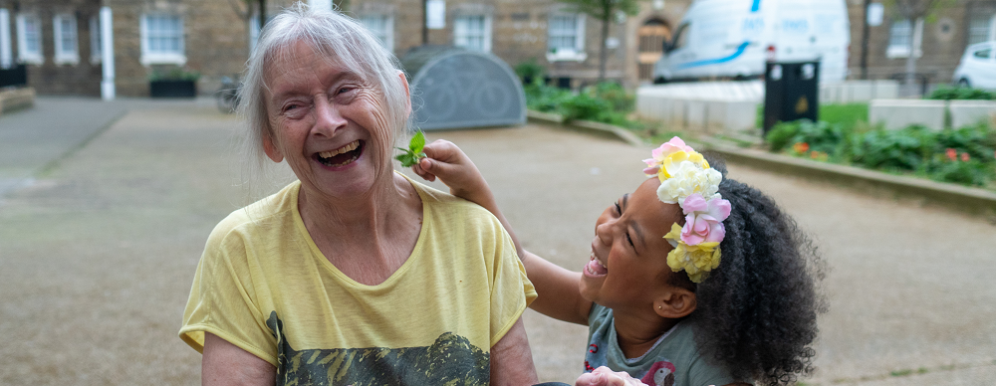
PRESS RELEASE [INSERT DATE HERE]
[FULL NAME] FROM [TOWN] TO TAKE PART IN [EVENT] FOR BRAIN & SPINE FOUNDATION.

[FULL NAME] from [TOWN] is taking on [NAME OF EVENT] on [DATE] to raise money for the Brain & Spine Foundation.

TIP: Make sure that the first paragraph includes the crucial information you want the people in your area to know about your event or fundraising efforts, eg who, what, where, when, why and how.
[NAME] is taking part because [INSERT REASON].

TIP: Enter a sentence or two here with your reasons for taking part– for example if you know someone who has been affected by a neurological condition.

[NAME] said: “It’s such a fantastic cause and I’m looking forward to raising as much money as possible.”

TIP: Feel free to personalise your quote with additional information too.

Lauren Ellis, Fundraising & Engagement Manager, said “We’re so grateful to [NAME] for organising this fantastic event and raising funds. The money raised will go directly towards supporting the 1 in 6 people across the UK living with a neurological condition.”

For more information about the event go to [INSERT YOUR FUNDRAISING PAGE LINK HERE].
The Brain & Spine Foundation is a lifeline for the 12 million people in the UK living with any of the 600+ known neurological conditions. The charity aims to drive change and dramatically improve quality of life. Find out more at www.brainandspine.org.uk.

–ENDS–

For further information, please contact:
[INSERT YOUR CONTACT NAME]
Tel: [INSERT YOUR PHONE NUMBER]
For media enquiries, please contact:
Engagement Team
Brain & Spine Foundation
Tel: 0203 096 7880
Email: info@brainandspine.org.uk

NOTES TO EDITORS
The Brain & Spine Foundation is a lifeline for the 12 million people in the UK living with any of the 600+ known neurological conditions. We aim to drive change and dramatically improve quality of life.
Professional Neuro Services
Neurological conditions are complex and resources are scarce. People wait for a long time for diagnosis while living with the stress of uncertainty. We provide free, professional help for any condition, and for anyone affected:
Research: NeuroLifeNow
NeuroLifeNow gathers valuable first-person insight into the daily reality of living with a neurological condition and the difficulties of accessing treatment, care and support. We deliver results in real-time to influence positive change for our community.
Community: Neuro Changemakers
Any person affected by a neurological condition is a Neuro Changemaker. We aim to mobilise a community of experts by experience to create a network of local self-help groups across the UK. These groups contain the tacit knowledge of how best to navigate the health and care structures in their region, as well as addressing unmet need.
The Brain & Spine Foundation is entirely funded by voluntary donations.
For more information visit: www.brainandspine.org.uk

